1.a.

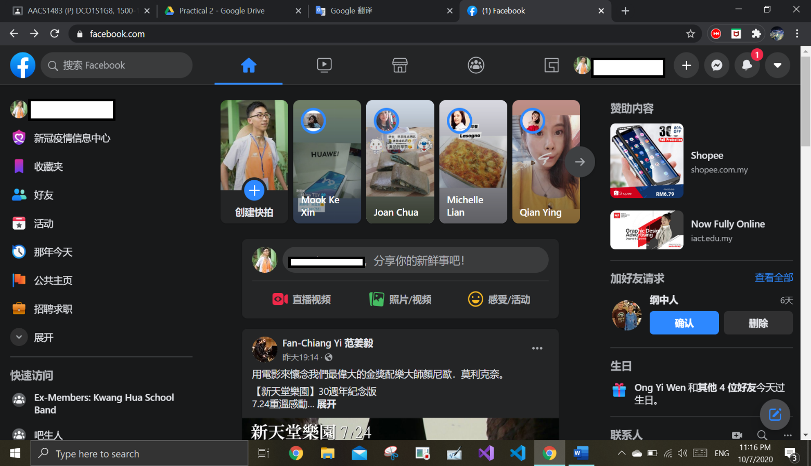

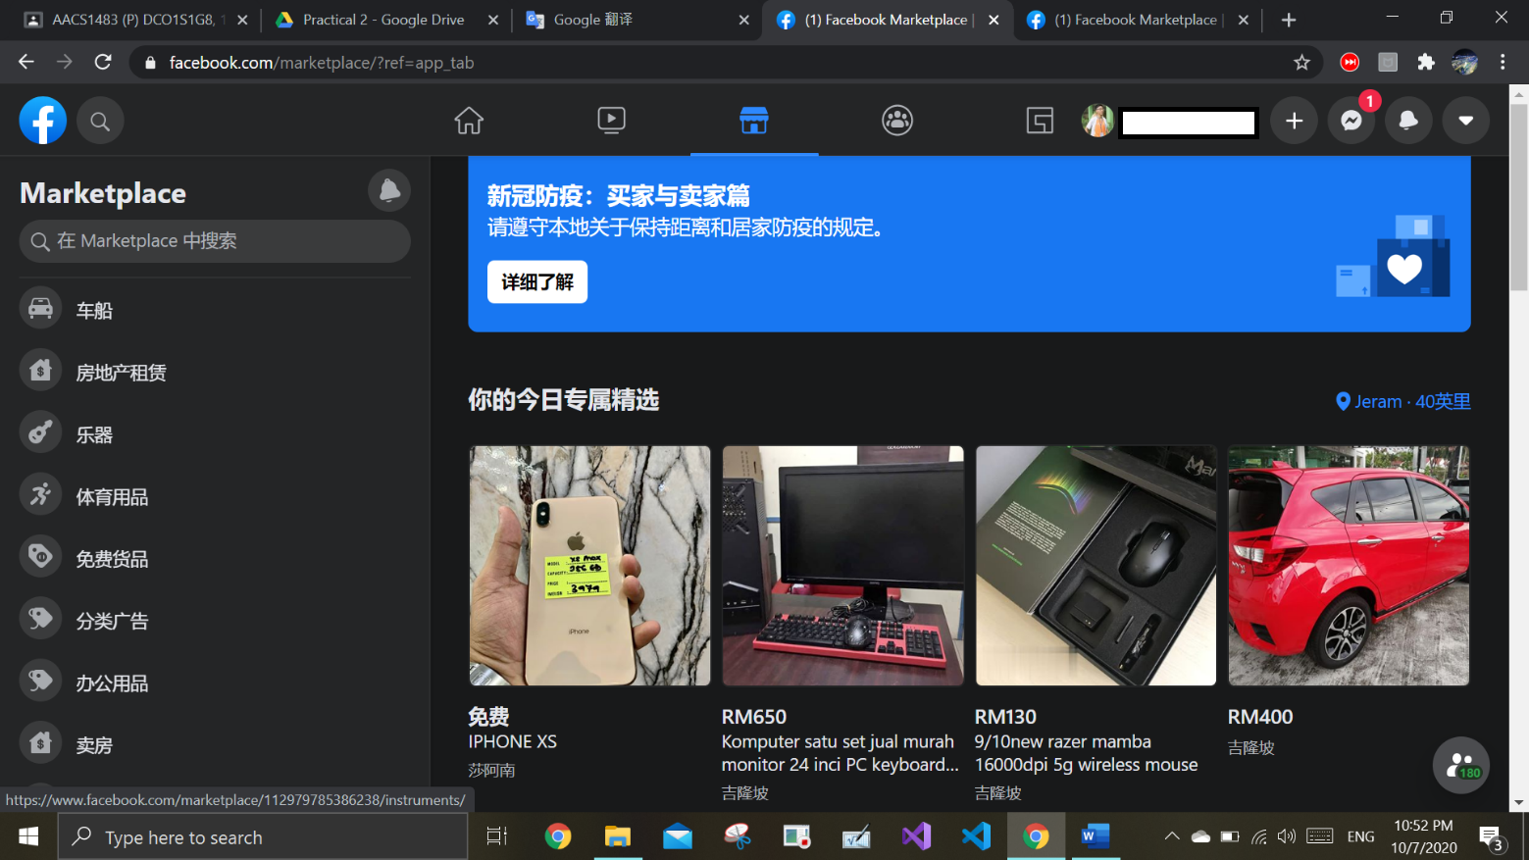

b.

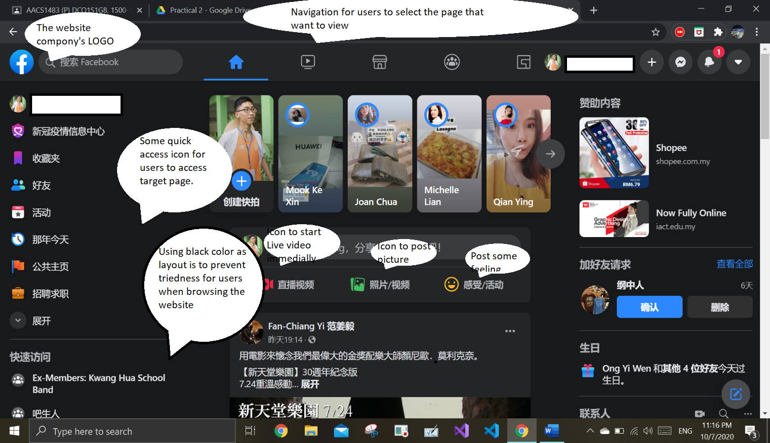

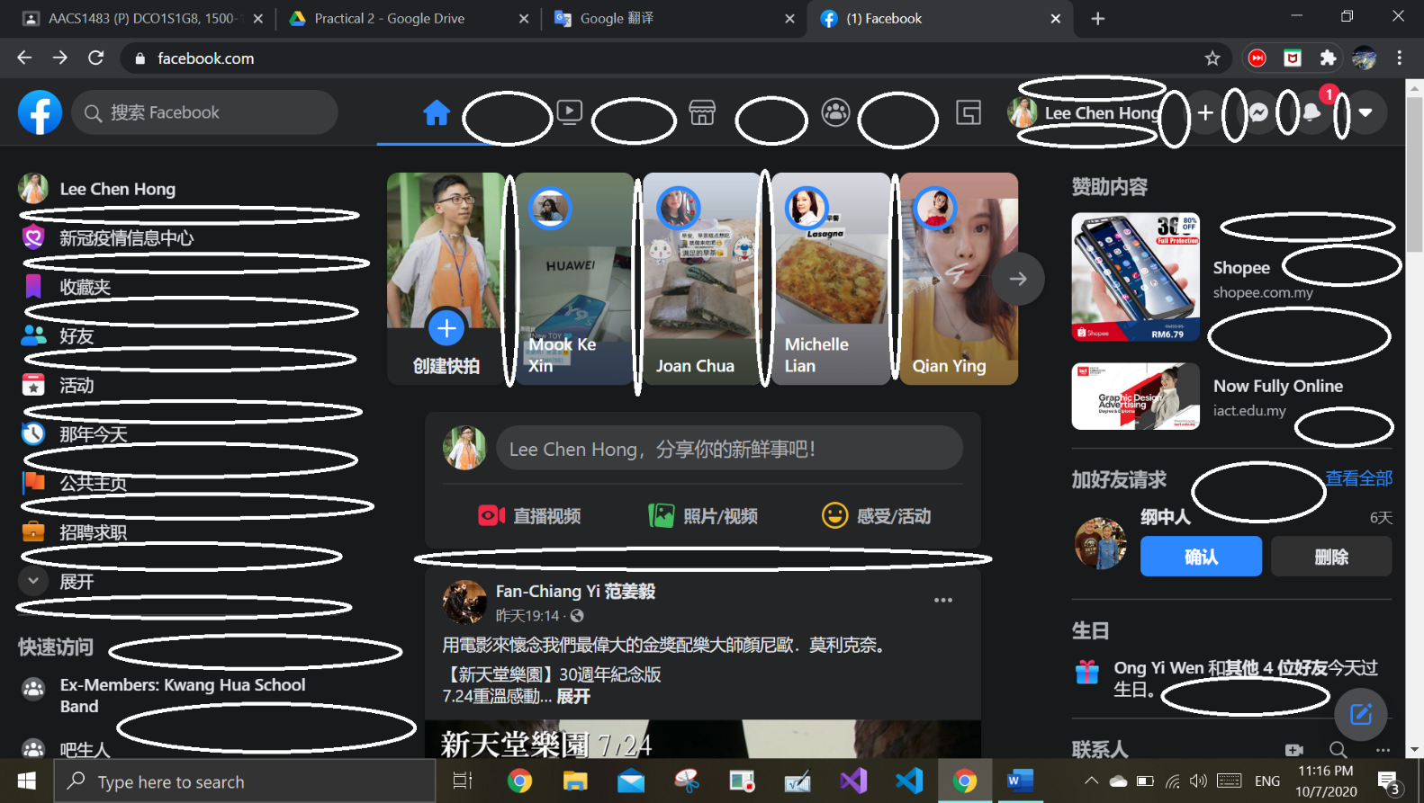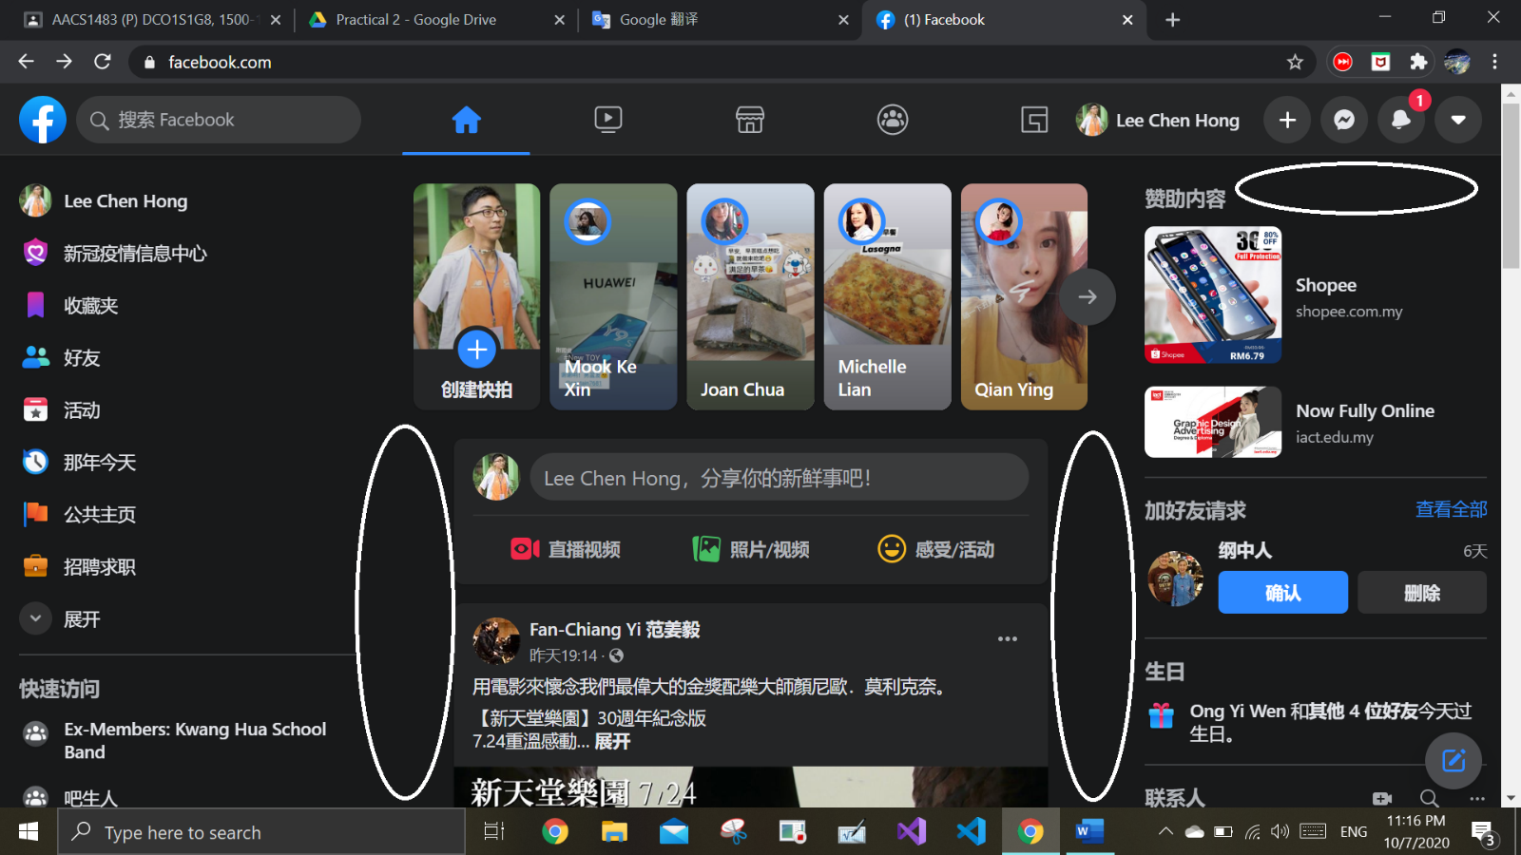c. Active White Page

D.

The website use the black color as main color of background. It is to prevent user from tiredness of eyes when using the website for a long time. Besides, the website use light blue as the feather of his company logo and major icon of the website. The icon or logo have a contract color from white color to blue color. It can keep fresh to user to look on the icon or logo. The color also have the function of attracting new users to browse the website. On the others hand, the website also insert many colorful icon to attract user to find out the function of the website can give.

Passive White Space

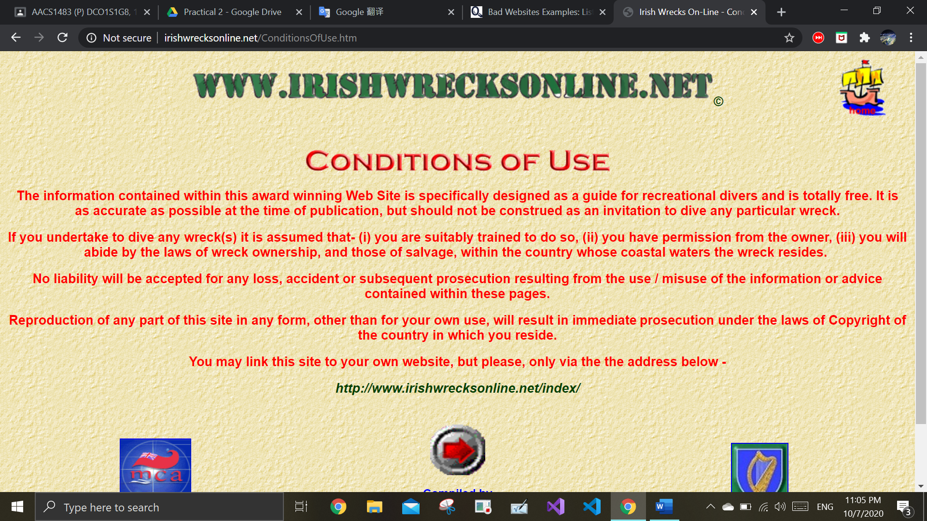2.A.

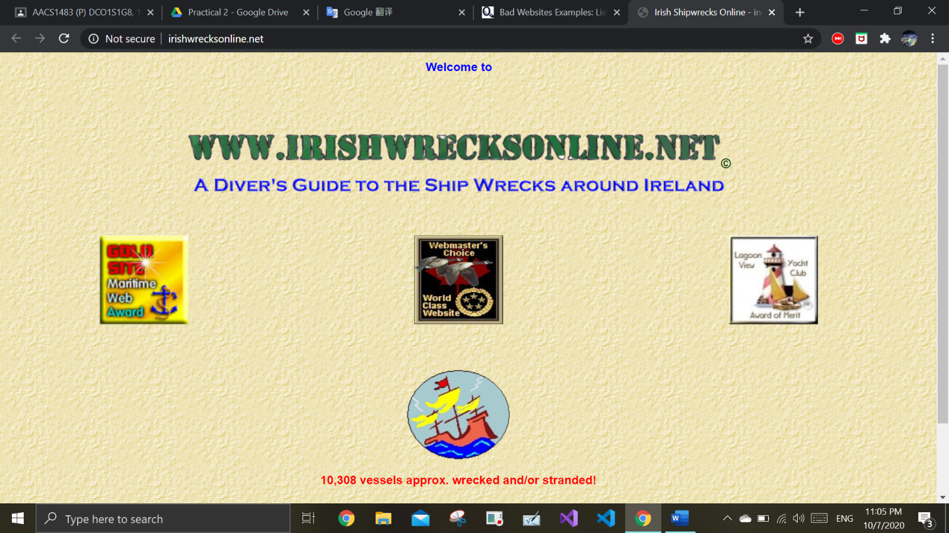

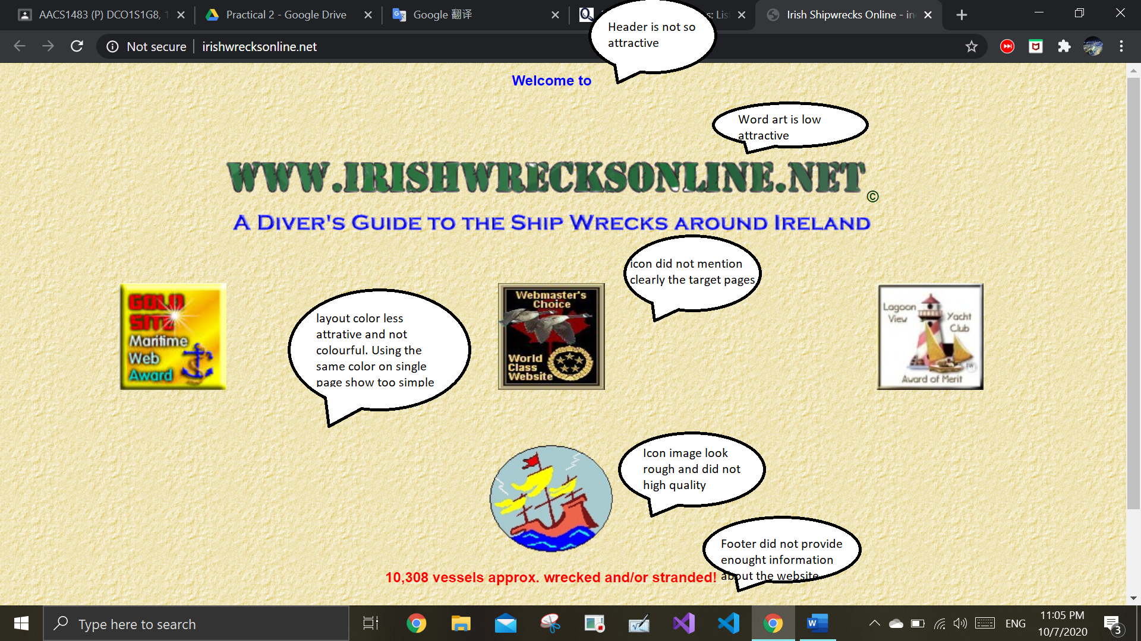b.

c.The website programmer can improve by mention clearly the themes of the website that users/client browsing on.Besites, they can code a nevigation bar instead of using icon.Icon can be used on the third party website that related with the website.Such as, Facebook account, Instagram account, Twitter account and more. On the others hand, they also can use some colorful layout on their website to attract users to continue browsing the website. Lastly, they can code a footer with providing information about the website.Such as, E-mail and contact number for website users report bugs to programmers when they using the website.

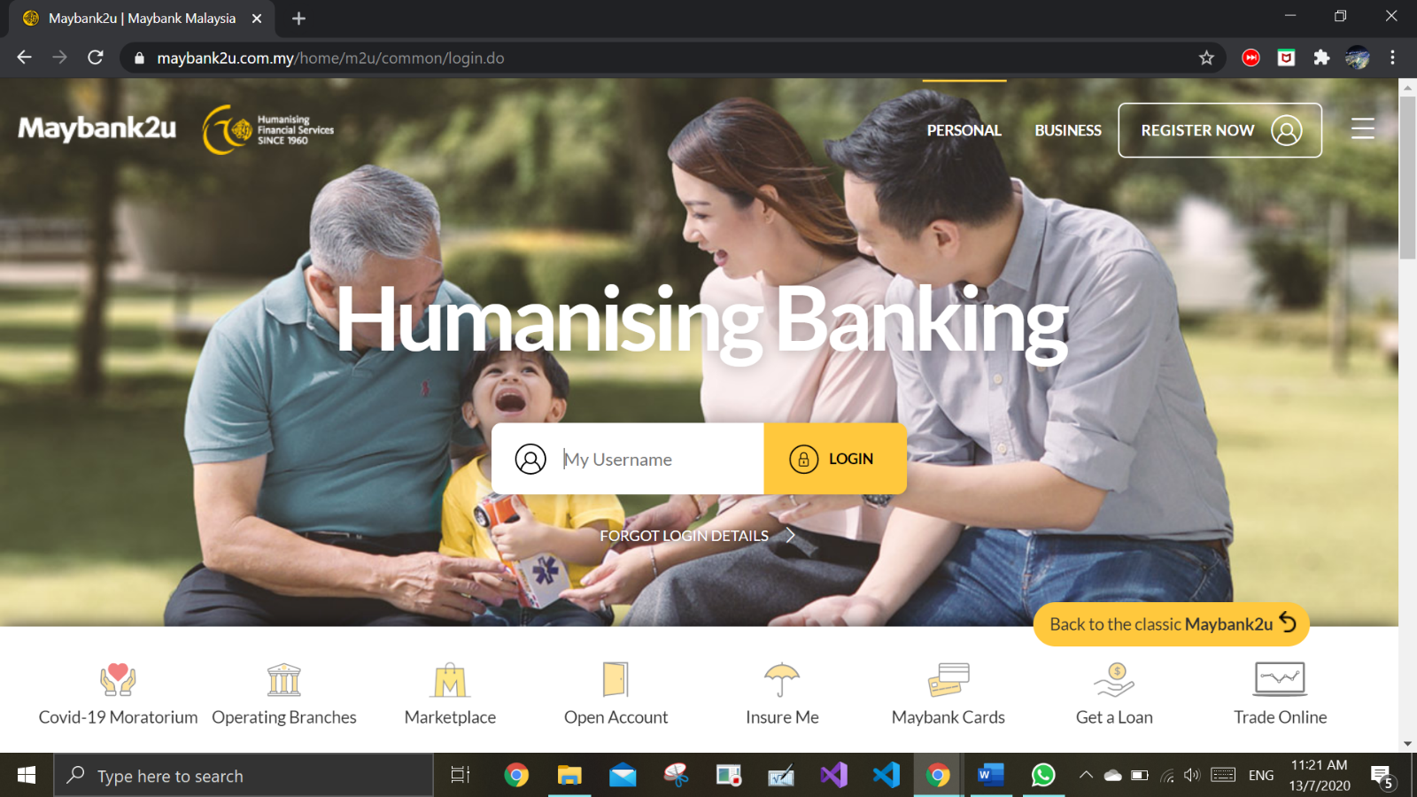a.

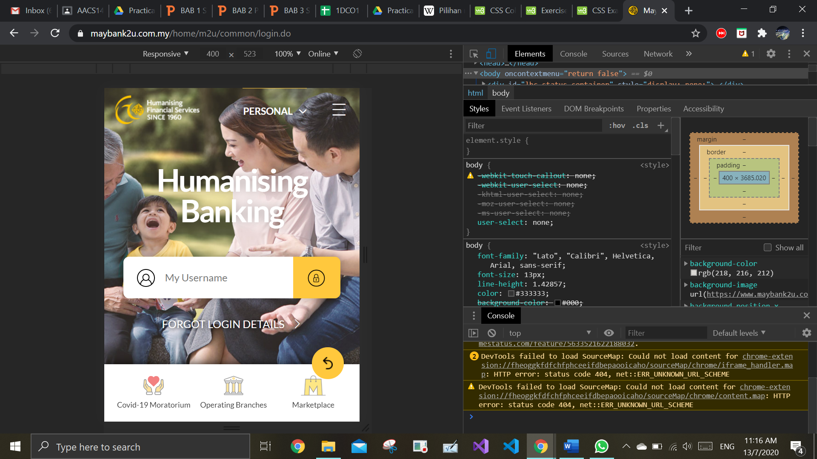b.

c.Maybank2u website showed a clear title for users when using it.The website programmers also provide nevigation with word were help users to reach their target page.The website also used yellow color same as their company’s logo to become layout of the website. Besides that, they also provided a blank on the centre of website to let users to log in their accounts. On the others hand, the images inserted clear and icons also was sample to let users understand them.Between using different devices, the website didn’t have many changes made.